**DAILY REPORT**

**Student Name :SINDHU.N**

**Class and Sec : VI B**

**USN :4AL17CS094**

**DATE:11-08-2020**

|  |  |  |  |  |
| --- | --- | --- | --- | --- |
| **Online Test Details** | | | | |
| **Subject** | ------ | | | |
| **Semester** | VI -B | | **Duration** | ----------- |
| **% of marks** | | ---- | | |

|  |  |  |  |
| --- | --- | --- | --- |
| **Certification Course Details** | | | |
| **Course** | Cyber Security | | |
| **Certificate Provider** | Great Learning | **Duration** | 5.5hours |

**Snapshots of the daily class acitivities .**

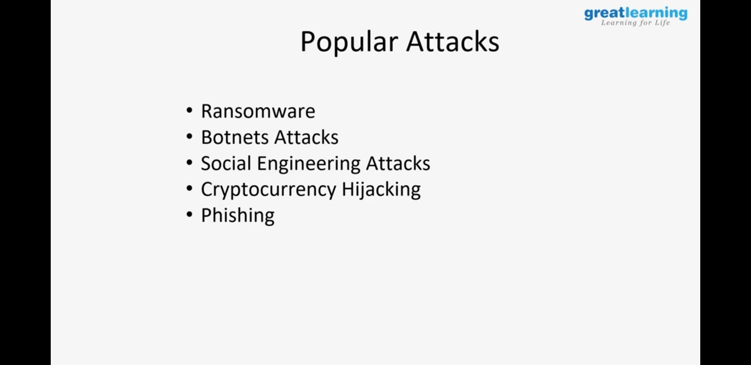



|  |  |
| --- | --- |
| **Coding Challenges** | |
| **Problem Statement:** 1. **Python Program for Number of solutions to Modular Equations.** | |
| **Status:** Executed | |
| **Uploaded the report both in Github & Slack** | Yes |

**Snapshots of your response to challenge.**

1. ****Python Program for Number of solutions to Modular Equations.****

**import math**

**def calculateDivisors (A, B):**

**N = A - B**

**noOfDivisors = 0**

**a = math.sqrt(N)**

**for i in range(1, int(a + 1)):**

**if ((N % i == 0)):**

**if (i > B):**

**noOfDivisors +=1**

**if ((N / i) != i and (N / i) > B):**

**noOfDivisors += 1;**

**return noOfDivisors**

**def numberOfPossibleWaysUtil (A, B):**

**if (A == B):**

**return -1**

**if (A < B):**

**return 0**

**noOfDivisors = 0**

**noOfDivisors = calculateDivisors;**

**return noOfDivisors**

**def numberOfPossibleWays(A, B):**

**noOfSolutions = numberOfPossibleWaysUtil(A, B)**

**if (noOfSolutions == -1):**

**print ("For A = " , A , " and B = " , B**

**, ", X can take Infinitely many values"**

**, " greater than " , A)**

**else:**

**print ("For A = " , A , " and B = " , B**

**, ", X can take " , noOfSolutions**

**, " values")**

**A = 26**

**B = 2**

**numberOfPossibleWays(A, B)**

**A = 21**

**B = 5**

**numberOfPossibleWays(A, B)**

****OUTPUT****

